### 

### Semester Two Examination, 2021

### Question/Answer booklet

# SPECIALIST MATHEMATICS

**UNITs 3 & 4**

## Section One:

## Calculator-free

|  |
| --- |
|  |

Your Name

Your Teacher’s Name

## Time allowed for this section

Reading time before commencing work: five minutes

Working time: fifty minutes

## Materials required/recommended for this section

***To be provided by the supervisor***

This Question/Answer booklet

Formula sheet

***To be provided by the candidate***

Standard items: pens (blue/black preferred), pencils (including coloured), sharpener, correction fluid/tape, eraser, ruler, highlighters

Special items: nil

## Important note to candidates

No other items may be taken into the examination room. It is **your** responsibility to ensure that you do not have any unauthorised material. If you have any unauthorised material with you, hand it to the supervisor **before** reading any further.

|  |  |  |  |  |  |
| --- | --- | --- | --- | --- | --- |
| Question | Mark | Max | Question | Mark | Max |
| 1 |  |  | 5 |  |  |
| 2 |  |  | 6 |  |  |
| 3 |  |  | 7 |  |  |
| 4 |  |  | 8 |  |  |

**Structure of this paper**

|  |  |  |  |  |  |
| --- | --- | --- | --- | --- | --- |
| Section | Number of questions available | Number of questions to be answered | Working time (minutes) | Marks available | Percentage of examination |
| Section One:  Calculator-free | 8 | 8 | 50 | 51 | 35 |
| Section Two:  Calculator-assumed | 13 | 13 | 100 | 101 | 65 |
|  |  |  |  | **Total** | 100 |

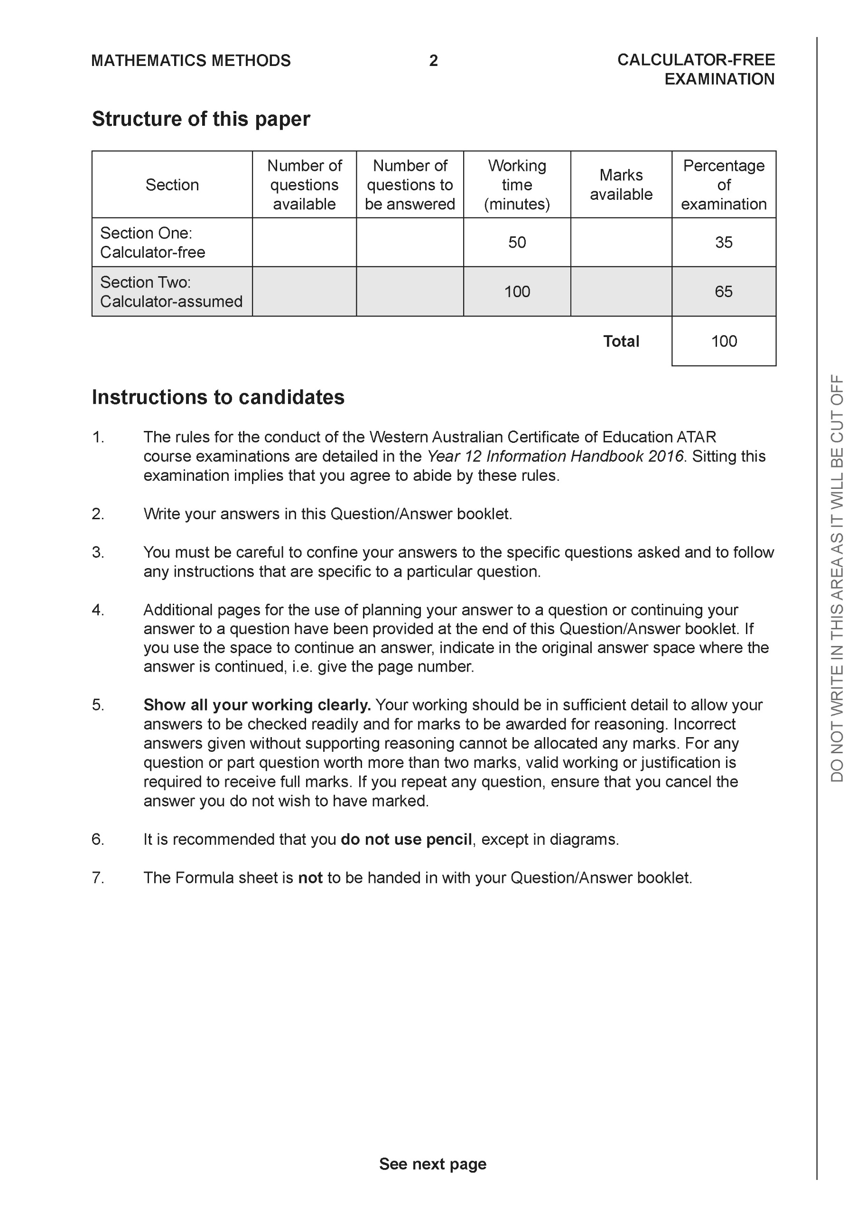

**Section One: Calculator-free (50 Marks)**

This section has **eight (8)** questions. Answer **all** questions. Write your answers in the spaces provided.

Spare pages are included at the end of this booklet. They can be used for planning your responses and/or as additional space if required to continue an answer.

● Planning: If you use the spare pages for planning, indicate this clearly at the top of the page.

● Continuing an answer: If you need to use the space to continue an answer, indicate in the original answer space where the answer is continued, i.e. give the page number. Fill in the number of the question that you are continuing to answer at the top of the page.

Working time: 50 minutes.

**Question 1 (4 marks)**

Evaluate 

|  |
| --- |
| **Solution** |
|  |
| **Specific behaviours** |
| P uses double angle formula  P integrates all terms  P evaluates upper limit  P states exact value |

**Question 2 (6 marks)**

Consider a plane that contains the following points .

1. Determine a normal vector to the plane. (4 marks)

|  |
| --- |
| **Solution** |
|  |
| **Specific behaviours** |
| P determines one vector in plane  P determines two vectors in plane  P uses cross product  P gives a normal vector |

1. Determine a cartesian equation for the plane. (2 marks)

|  |
| --- |
| **Solution** |
|  |
| **Specific behaviours** |
| P determines vector equation  P states cartesian equation |

**Question 3 (6 marks)**

Sketch the function  on the axes below, labelling important features.

|  |
| --- |
| **Solution** |
|  |
| **Specific behaviours** |
| P vertical asymptotes dotted and labelled with equation  P horizontal asymptote dotted and labelled with equation  P approx. y intercept correct  P both x intercepts correct exactly  P shape correct between vertical asymptotes  Poverall shape is correct for all x values |

**Question 4 (6 marks)**

1. Solve the following system of linear equations. (3 marks)



|  |
| --- |
| **Solution** |
|  |
| **Specific behaviours** |
| P eliminates one variable in two equations  P eliminates two variables in one equation  P solves for all variables |

1. Solve for all possible values of  for the system below for each of the following scenarios. (3 marks)



1. Unique solution.
2. Infinite solutions
3. No solutions.

|  |
| --- |
| **Solution** |
| i)  ii)  iii) |
| **Specific behaviours** |
| P eliminates two variables  P states values for uniqueness  P states values for infinite and no solns |

**Question 5 (6 marks)**

Consider the function  drawn below.

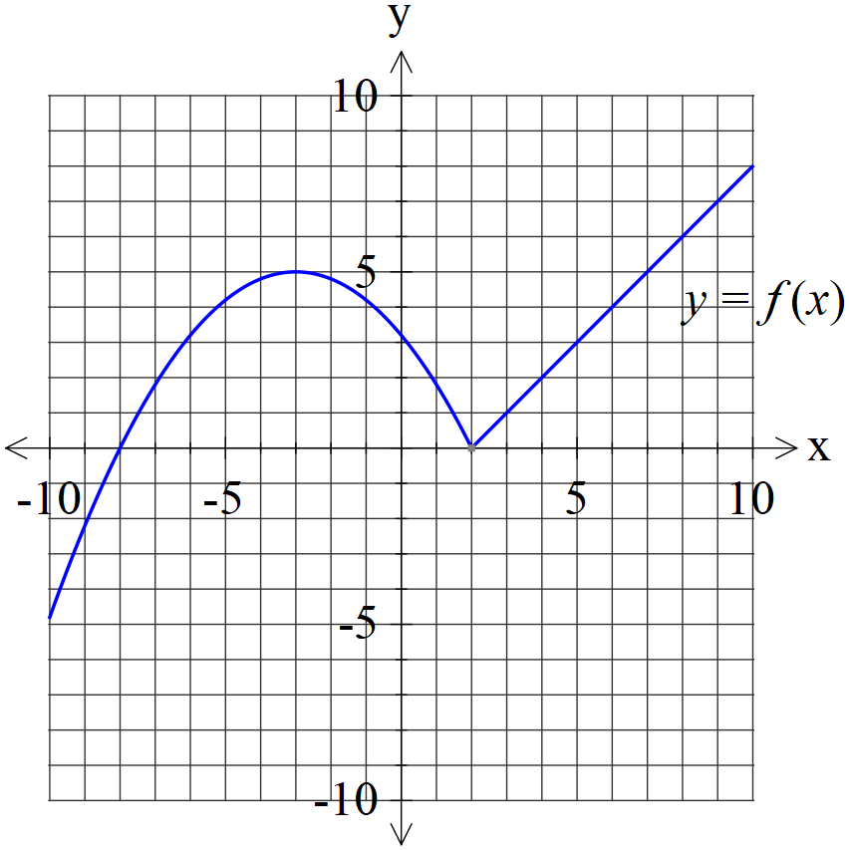

1. Plot  on the axes below. (2 marks)

|  |
| --- |
| **Solution** |
|  |
| **Specific behaviours** |
| P reflects right side  P x & y intercepts correct |

1. Plot  on the axes below. (4 marks)

|  |
| --- |
| **Solution** |
|  |
| **Specific behaviours** |
| P both asymptotes for y>0  P approx y intercept and turning pt for y>0  P shape for y>0  P shape for y<0 |

**Question 6 (9 marks)**

Consider the function  with domain .

Let .

1. Determine the domain and range of . (2 marks)

|  |
| --- |
| **Solution** |
|  |
| **Specific behaviours** |
| P domain  P range |

1. By using implicit differentiation show that  is of the form  where  is a constant. (4 marks)

|  |
| --- |
| **Solution** |
| (Note: accept ) |
| **Specific behaviours** |
| P replaces x & y  P implicit diff wrt x both sides  P uses Pythagorean identity  P expresses in required form |

1. Evaluate  with substitution . (3 marks)

|  |
| --- |
| **Solution** |
|  |
| **Specific behaviours** |
| P changes limits  P simplifies in terms of u  P integrates and states final result |

**Question 7 (7 marks)**

1. Given that  with  constants. Solve for . (4 marks)

|  |
| --- |
| **Solution** |
|  |
| **Specific behaviours** |
| P sets up am equation with all constants  P shows working on solving for 2 constants  P solves for 3 constants  P solves for 4 constants |

1. Hence determine an expression for . (3 marks)

|  |
| --- |
| **Solution** |
|  |
| **Specific behaviours** |
| P integrates one term  P integrates two terms  P integrates all terms and adds a constant |

**Question 8 (7 marks)**

Evaluate the following integrals.

1.  (3 marks)

|  |
| --- |
| **Solution** |
|  |
| **Specific behaviours** |
| P uses a change of variable  P expresses integral in terms of new variable and integrates  P changes limits and **subs** into final expression (no need to simplify) |

1.  (4 marks)

|  |
| --- |
| **Solution** |
|  |
| **Specific behaviours** |
| P uses u=tanx  P uses partial fractions and shows working for constants  P integrates wrt new variable  P expresses in terms of x (unsimplified)  Note: Follow through for last two marks only if partial fractions used |

Additional working space

Question number:

Additional working space

Question number:

Additional working space

Question number:

**Acknowledgements**